**SCRIBNER-SNYDER COMMUNITY SCHOOLS**

**DECEMBER, JANUARY, FEBRUARY NEWSLETTER**

**2024-25**

**FROM THE DESK OF THE SUPERINTENDENT By Joe Peitzmeier**

**As I write this, the fall sports/activity season has come to a close and the winter sports/activity season is about to begin, and I am getting ready to set my clock back. By the time you read this newsletter, I am in hopes that you have recovered from an enjoyable Thanksgiving feast and special time with family. The annual Veteran’s Day program sponsored by the Scribner-Snyder Community Schools and the Scribner Chamber was held. Thanks to everyone that had a part in this outstanding tribute to our veterans. This program helps remind me to be thankful to the veterans for the sacrifices that they have made so that we can live the way we do in the greatest nation on earth.**

**I want to assure you that our teachers, support staff, and administration continue to be very proactive in continuing to provide the fine educational tradition at Scribner-Snyder Community Schools. We continue to evaluate curriculum, upgrade technology, fine tune testing procedures, and build on our Positive Behavior Support System in order to improve the education of our youth. We truly want what is best for our kids. We have several groups that meet often to discuss issues that may affect our school climate and culture. If you have concerns or questions, please call and set up a meeting to discuss. I do not participate in the social media world, but I have been informed of several negative posts about incidents at school. That avenue of communication does nothing to help rectify any issue and often only adds to the anxiety of those involved. Please open a direct dialogue with the teacher, support staff member, or administrator so we can have an adult discussion to work as a team. We all want a positive outcome. As always, my door is open. If you have concerns pertaining to the schools—do not hesitate to contact me.**

**In closing, I want to wish everyone a Merry Christmas and a prosperous New Year! *HAPPY HOLIDAYS!***

**FROM THE PRINCIPAL’S DESK**

***Dear Scribner-Snyder Community School Patrons,***

***The school year is flying by.  We are almost halfway through.  There are a lot of activities going on in the next few weeks.  Boys’ and girls’ basketball and wrestling seasons have started.  On November 19th we hosted East Husker Conference One- Act.  Our students and coach did an amazing job at the conference competition.  We ranked 3rd out of 8 teams.  On Dec 4th we will host District One-Act.  This event is open to the public.  Please come out and enjoy the day with us.***

***On November 11th, we celebrated Veterans Day.  Coffee and cookies were served before the program and lunch was served afterwards to our local legion and auxiliary members.  The students did a wonderful job with the program.  A special thank you goes to Mrs. Schafer, Ms. Rangeloff, Mr. Poessnecker, Sharon, Deb, and Becky & the kitchen staff for helping to prepare for a wonderful event.***

***Our winter music programs are around the corner.  The elementary concert will be on Friday, December 13th at 7:00 p.m. and the Jr./Sr high school concert (Grades 6-12) will be on Sunday, December 15th at 2:00 p.m.  The Senior Class will be hosting a luncheon before the high school concert from 11:30 – 1:30 p.m.  As mentioned above, we welcome all to attend.  We have some talented students.***

***Just a couple of reminders as we move into the winter season.  Please keep your child at home if he or she is running a temperature or feeling ill.  Students with a temperature over 100 degrees will be sent home.  Students must be fever free for 24 hours without medicine before returning to school.  We ask that if your child has vomited or has bowel issues due to sickness, please make sure your child is feeling well enough before returning to school.***

***Also, make sure all phone numbers are up to date.  We will be using our school messenger phone system to call parents if there is a cancelation due to weather or for any other possible notifications.***

***Mark your calendars, December 20th is the end of the first semester and last day of classes.  There will be a full day of school.  Classes will resume on January 7, 2025.***

***In closing, we wish you all safe and happy holidays.***

***Respectfully,***

***Mrs. Nemecek***

**School Closing/Dismissal Information**

**\*Please understand that safety for students is the main concern in the decision to close schools.**

**\*When school is dismissed early for bad weather, students who drive their own vehicles and live outside the city limits will be required to contact their parents by telephone prior to leaving school.**

**\*Bus/van students will ride home as usual.**

**\*My main contact is KTIC AM 840 & FM 107.9 radio and TV channels 3, 6, or 7 in Omaha for any school closing, late start, or early dismissal due to threatening weather. I will also attempt to contact KFAB 1110 radio.**

**\*We will also send out an all call to family’s phones through School Messenger**

**\*On late starts, we typically plan to start school 2 hours late. We realize that some roads are more hazardous than others and we do not expect students or parents to endanger their safety in order to get to school. If a student legitimately cannot get to school because of weather conditions, they will be excused.**

This year’s 3rd grade class has been super busy! We have been doing a lot of multiplication and division in math. Kids are picking it up quickly and working hard to get their facts memorized. They are also learning to do area and the perimeter of objects based on side lengths. Doing new things seems to challenge and excite this group which is very exciting for me to see as a teacher.



[This Photo](https://kotoba.wiki/t/81-multi/19410) by Unknown Author is licensed under [CC BY-SA](https://creativecommons.org/licenses/by-sa/3.0/)

Science has been equally busy. Students are studying different types of life cycles and organism traits they inherit from their parents. Students started with plant life cycles and traits and now are working with animal life cycles and traits. They have been able to identify different stages of animal and plant life cycles and predict what the offspring of parents will look like based on the parental traits. We have done several experiments and students are excited about completing these experiments.

Our class has had an incredible start to the year, and they have been working hard to make goals and reach those goals. I am very proud of the progress we have made so far as a class. Students and teachers have been working well together and getting some very impressive achievements done. It is looking like we will be on track come Christmas break! It’s a GREAT day to be a Trojan!

**Adventures in Life Skills**

**This year has flown by and in Like Skills we are busy as ever.  The students have been enjoying cooking Halloween treats in October, Thanksgiving recipes in November, and holiday recipes are coming up in December.  We continue to work on our budgeting projects and learn how to balance an account and pay our bills.  We’re even doing research on what to do when you are moving from town to town.**

*SSCS reaching their potential* Mrs. Laura Enos

Language Arts has always been my favorite subject since I was a young child and bringing out students’ talents and skills that will help them reach their highest potential will continue to be my professional goals while leading my classroom in the curriculum areas of English, Public Speaking, Reading and Yearbook.

9th grade English is designed to give all freshmen an opportunity to sample and be exposed to each main literary genre and subgenres, review grammatical rules and functions, and become even more confident in their personal narrative and expository writing abilities.  We have concluded a graphic novel unit and are embarking on a research paper on a well-known person of interest.

Sophomores have started their novel unit, Harper Lee’s classic novel, *To Kill a Mockingbird.* Students will be exposed to many literary classics throughout the year and will be introduced to analytical writing and deeper-level literary discussions. 10th graders also take a Communications class first semester targeting public speaking skills and a Creative Writing course second semester, which has always been a fan favorite.

The 11th graders have been discussing, creating, and reading about the universal theme “Identity/Individuality”. American Literature, argumentative/persuasive writing, and ACT preparation is the bulk of the junior curriculum. Seniors have the option of either English 4 or Dual Credit through Peru State College.  Both options offer a composition/writing focus in the fall semester and a literature-based course in the spring semester.

9th-12th graders also have the option to be a part of the Yearbook staff where we have been learning the ins and outs of Photojournalism, cover design, story writing, theme conception, and photo editing. This year’s staff has come up with a special and fitting theme as the focus for this year’s publication.

This year I gained the 6th grade Reading students and it’s been a great addition to my schedule.  The students seem to enjoy our readers theater opportunities the most but are open to reading and enjoy discussing the variety of stories the 6th grade curriculum provides.

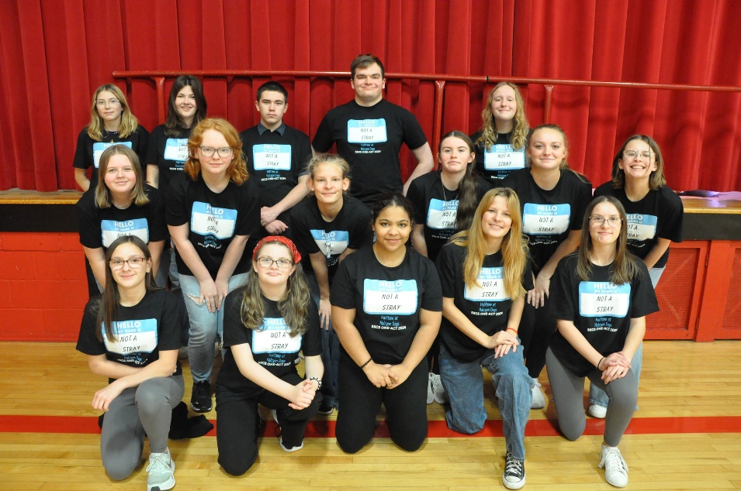First semester also means it’s One-Act season and the 16 participating students in the cast and crew have been demonstrating impressive teamwork as they create a comedic performance for this year’s production. Come watch our community performance in the SSCS gym on the evening of Monday, December 9th!

***The Trojan Hut has been busy*** this year adding new products to their line. They have partnered with The Nook to offer seasonal and school pride apparel. They also received their new mobile cart purchased through Perkins funding. Keep an eye out in the months to come, as they are hoping to debut the cart at home sporting events!

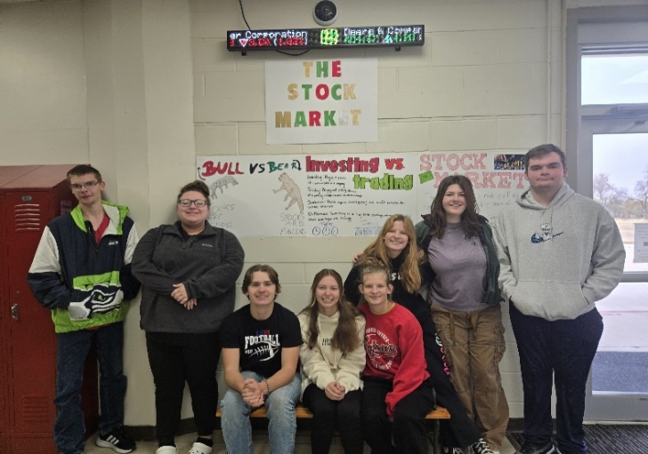The Personal Finance classes just wrapped up the module on credit and credit management. They learned about the different types of loans available, including personal loans, car loans, and mortgage loans. They also learned how credit cards work, and the different components of credit scores and credit reports.

New in the business department this year is the scrolling ticker display! Students are excited for their upcoming investing unit to start learning more about stocks and investing and using the scrolling ticker display to keep an eye on the market. Curious what the scrolling ticker display looks like? Check the Scribner-Snyder Community School’s Facebook page for a picture of it!

The students in the Introduction to Business class are putting finishing touches on their leadership projects. They had fun learning about a famous leader, including their leadership styles. Students are also eagerly awaiting their field trips to different businesses in Fremont and Scribner. They are excited to see how the businesses started, and to ask questions to learn more about the business process.

**School Foundation Reorganization**

The Scribner-Snyder Community Educational Foundation (SSCEF) is undergoing a revitalization to expand its focus on supporting students, enhancing programs, and benefitting the community.

Originally formed in 1998, the SSCEF, made up of various community members and school administration, has long aimed to enhance opportunities for Scribner-Snyder students.

This year, the board has reorganized the foundation, bringing it back to life, to not only help secure tax-exempt status to open more opportunities for the students but to help the community as well. The new board members are John Mauch, Myron Groppe, Steve Swanson, Angie Brainard, Janis Baker, Megan Stock, and Joe Peitzmeier.

The newly appointed directors are currently revising the foundation's By-Laws and Articles of Incorporation to support the goals of this renewed initiative.

The foundation's main objective continues to be the support of students and teachers, which has been its mission since its establishment 25 years ago. Throughout the years, it has successfully raised funds for student scholarships and has sponsored the annual Teacher of the Year Award.

But the newly established foundation has added a second priority: enhancing Scribner-Snyder Community Schools by focusing on facility upgrades, technology improvements, and curriculum development. As state and federal funding continues to waiver, public schools increasingly depend on local tax dollars to fulfill their needs.

The third priority the foundation is looking to tackle is addressing the lack of childcare our rural community has been faced with. The goal is to support an Early Childhood Day Care program. The foundation believes this is a very valuable resource for our district and important to the economic development of our town.

The Scribner-Snyder Community Educational Foundation allows individuals, groups and businesses to support the school district with tax-deductible contributions. The foundation operates independently of tax dollars, and donations it receives do not replace any tax funding used to run the school district.

Anyone looking to make a contribution, regardless of size, is greatly welcomed and appreciated by the foundation.

Those with questions about the foundation, interested in establishing a scholarship fund, or wishing to make a donation are encouraged to reach out to any foundation board member or Joe Peitzmeier, the SSCS superintendent.

***NEW PROGRAM IS A HIT AT SSCS!!***

The JAG Nebraska students at SSCS have gotten the program off to a strong start! Students have been working on their class projects, engaging with employers, demonstrating professionalism and leadership, and visiting educational institutions. The junior and senior JAG classes have been putting together a school carnival proposal, and the juniors have also been building a model of a rollercoaster for it. The 7th and 8th Grade JAG students put together a presentation plan for their dream vacation that they researched and looked up photos for with every detail from the price to where they will sleep and eat planned out.

Some of the tours students have had the opportunity to be a part of are: Smeal Fire Apparatus in Snyder, Canine Country Club, and Werner Trucking. They have had the opportunity to visit with a variety of guest speakers as well. Lana Minton, an event planner from the Fremont Family YMCA, came to visit with our students and gave them a free pass to try the YMCA in Fremont for a week. David Kruger who is the Washington County Highway Superintendent also spoke with our students. A few students toured Wayne State College, and a group will be visiting Midland University on December 3rd. Our High School JAG Officers represented us well at the JAG Nebraska Leadership Development Conference in October.

We held our Disco and Officer Instillation Celebration Ceremony on November 25th, and many more upcoming opportunities are scheduled for the remainder of the year.

**IMPORTANT DATES TO REMEMBER:**

December 4th—NO School—SSCS is hosting District Play Production

**December 5th—Boys Wrestling Quad @ SS-Parent’s Night, 5 p.m.**

December 9th-One Act/FCCLA Dinner/Performance, 6:30 p.m.—Please RSVP!!

**December 11/January 8/February 12-Board of Education meeting, 6:30 p.m.**

December 12th—Girls Wrestling Tri @ SS-Parent’s Night

**December 13th—Elementary Christmas Concert, 7 p.m.**

December 15th—Jr/Sr (6-12) Christmas Concert, 2 p.m./Sr. Class Soup & Sandwich Luncheon, 11:30-1:30 p.m.

**December 23--Jan. 6th—NO SCHOOL-CHRISTMAS BREAK**

February 28th--Ceramic/Clay Night @ SS

**As always, please check the sstrojans.org website for the most up-to-date**

**information and current events taking place at SS.**

***Junior High Wrestling season begins Dec. 3rd!***

I hope this newsletter finds you well and enjoying the beautiful moments that this season brings. As we transition into December, I want to take a moment to express my heartfelt gratitude for your continued support and partnership in our school community.

**Important Announcements:**

We have some exciting updates regarding our Junior High wrestling program:

* **Junior High Wrestling Practices:** Practices are held during 8th period.
* **All Girls Tournament:** Our first all-girls tournament will take place on **December 3rd** at Oakland Craig.

**Upcoming Junior High Wrestling Schedule:**

* Wisner Pilger: January 20th
* Oakland Craig (Boys Only): January 27th
* Wayne (Girls Only): January 31st
* Stanton: February 10th
* Norfolk (Girls Only): February 11th
* Pender (Boys Only): February 24th
* Malcolm: March 4th
* West Point-Beemer: March 10th

Please mark your calendars for these important dates!

We are thrilled to announce that girls' wrestling will officially begin in December! Currently, we have three junior high girls practicing for the wrestling season. We are excited about the potential and energy they bring, and we look forward to a fantastic season ahead for all our wrestlers.

As we prepare for the upcoming events, we encourage all families to stay engaged and support our young athletes. Your involvement makes a significant difference in their experiences and success